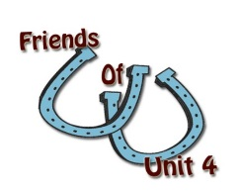 Support Our Schools
A new organization is being formed to support all activities in our Unit 4 schools
- Extra-curriculars, Classrooms, Facilities, Equipment, Transportation & More
Who Should Join
- Anyone one who wants to help keep our Unit 4 Schools an active and important part of our community
  - Alumni, both local and living outside the district
  - Parents, relatives, students and any community member who wishes to contribute time or funds in support of Unit 4 schools
What’s Next
- Fill out the form below and take it to First Bankers Trust, Mendon Office and watch for further information about our next big community event “Friends of Unit 4 Fall Festival” to be held October 8th at the Adams County Fair Grounds
Help our youth and our community by supporting Unit 4 with your time and your contributions!
___________________________________________________________________
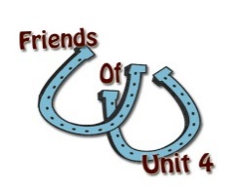 Friends of Unit 4 Membership

Name_____________________ Address ______________________________________

Ph: ________________ Home or Cell email: _______________________________

1 Year Membership Enclosed ($10 per person) ____________________
Lifetime Membership Enclosed ($100 per person) __________________
Additional Donation Amount: _________________________

